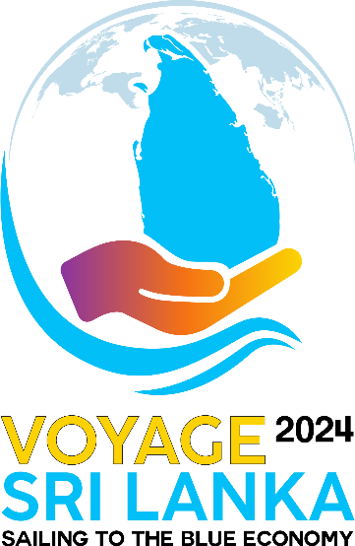

**Social media Links**

**----------------------------------------------------------**

Facebook Page

* <https://www.facebook.com/profile.php?id=61566945500172&mibextid=rS40aB7S9Ucbxw6v>

LinkedIn Page

* <https://www.linkedin.com/company/voyage-sri-lanka/>

Instagram Page

* <https://www.instagram.com/voyagesrilanka2024>

Official Website

* <https://voyagesrilanka.lk/>

Boat Building video

<https://www.youtube.com/watch?v=3LuEopKHlPA>

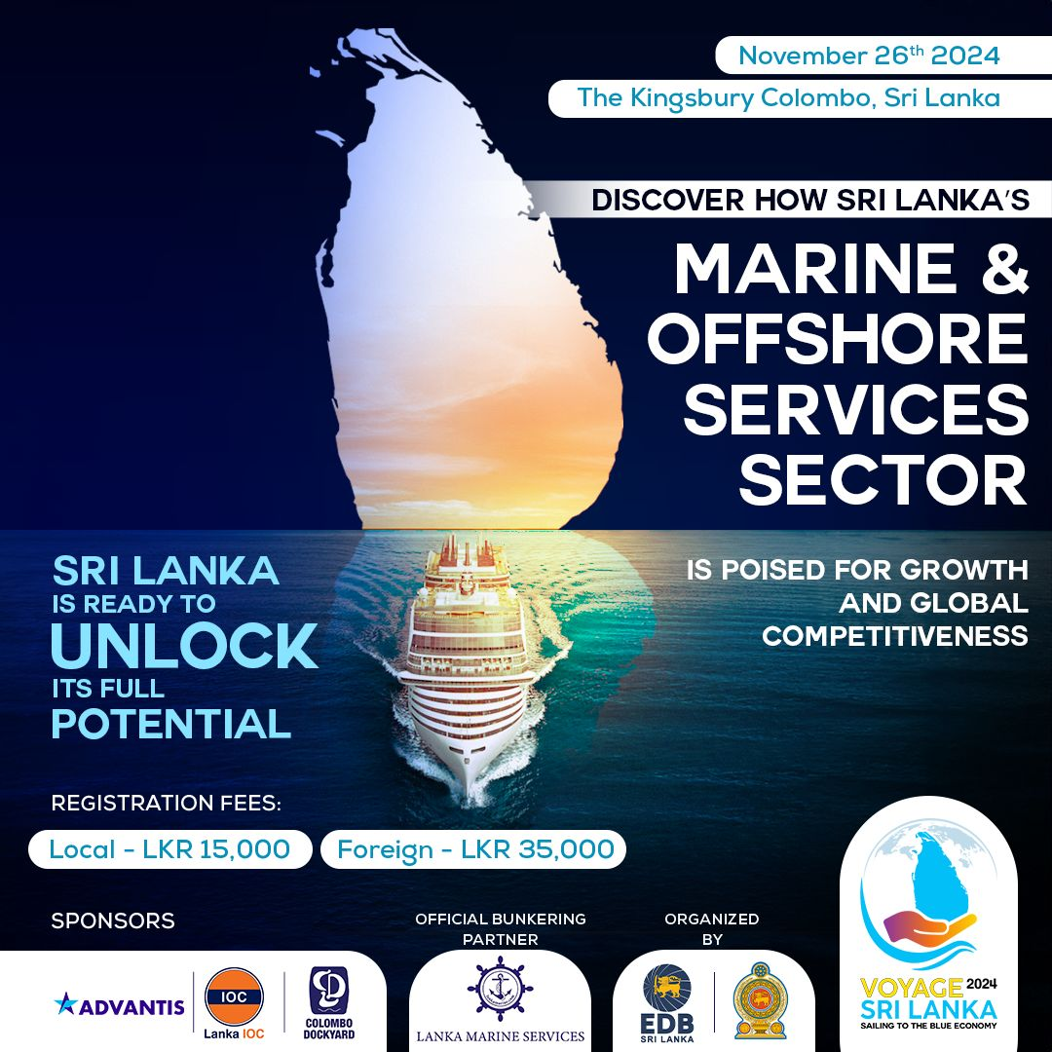Static Image to promote the event